**Classification**

**Classification algo is used to classify the input into category after training the dataset.**

**Types of classification**

**🡪Classifier**

**🡪Binary Classification**

**🡪Category(having only two category)**

**🡪Multicategory(more than 2)**

**🡪Classication model(based on input output predicted)**

**🡪Feature**

**🡪Multilabel classification**

**🡪Initialize(fit method)**

**🡪train,predict,eval**

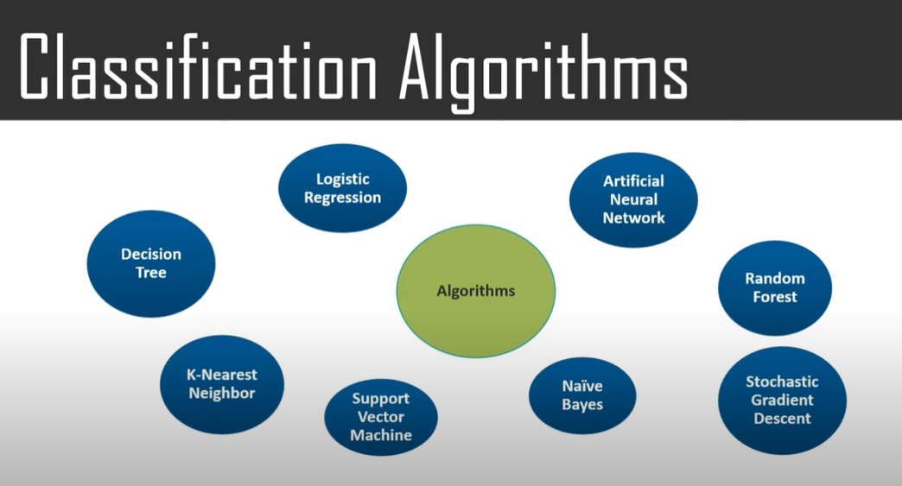

**For every algo 🡪**

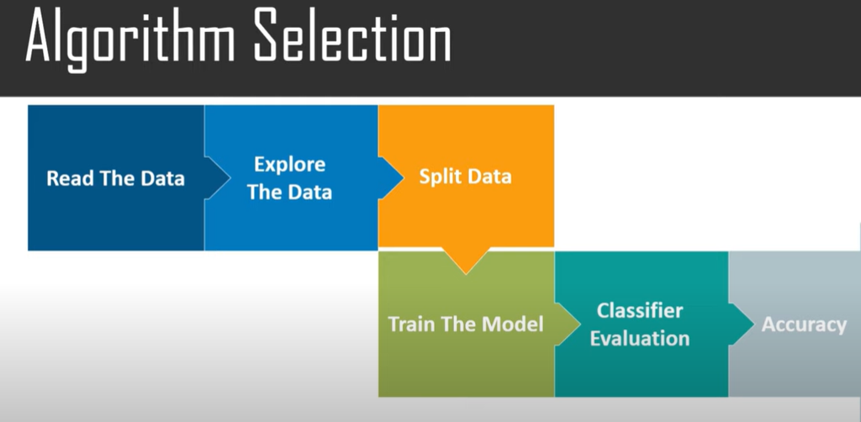

**For true false prediction must try logistic regression over other algo ,giving high accuracy.**